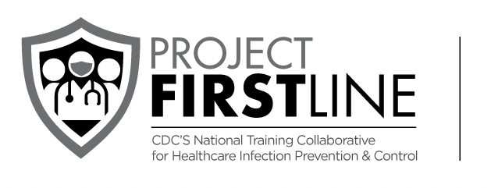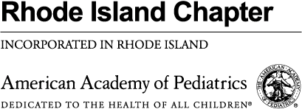

Register Now for Part 1 (of 3-Part Series):
April 13th 4-7pm, Providence Marriott https://www.eventbrite.com/e/recalibrating-risk-redefining-infection-prevention-in-the-community-tickets-292482371647

CDC’s Project Firstline Infection Prevention and Control Collaborative:
Recalibrating Risk & Redefining Infection Prevention in the Community
(conference & parking are free of charge and box dinner will be provided)

Part 1: Building Infection Control Mitigation Plans for Evolving Environments
Objectives:
  - Identify mitigation measures and implementation strategies to keep patients and team members safe
  - Discuss responding to changes in prevalence, seasonality, clusters, and trends of communicable diseases
  - Introduce and utilize tool for defining facilities’ infection control risk, facilitators, and barriers to implementing mitigation plan: Risk Needs Assessment

Presenters:
Michael Koster, MD, FAAP, Lifespan
Kristen Ferlisi, Lifespan
Haley Fiske, BSN, MPH, RN, Lifespan
Melissa Iannotti-Murdock, BSN, RN, CIC, CDC Foundation

Registration link is for Part 1 of a 3-part series. Additional information and schedule for parts 2 & 3 will follow. CME accreditation (pending) will be separate for the conference and webinar and available a few weeks before each session.

Part 2: Directly Assessing Various Facilities to Improve Baseline Infection Control Practices - May - June (walk through of selected facilities)
Objectives:
  - On-site assessment and cross collaboration
  - Complete Risk Needs Assessment with representatives of the hosting organization
  - Develop strategies to sustain/ maintain baseline infection control practice
  - Provide written summary to hosting organization

Part 3: Coming Home: Arriving to Practical Solutions - July (webinar for all)
Objectives:
  - Review community evaluations/walk through
  - Identify successful strategies and unanticipated barriers
  - Provide participants with toolbox for community infection prevention

More information and resources on CDC’s Project Firstline are available at: https://www.cdc.gov/infectioncontrol/projectfirstline/index.html
Project Firstline is a national collaborative led by the U.S. Centers for Disease Control and Prevention (CDC) to provide infection control training and education to frontline healthcare workers and public health personnel. American Academy of Pediatrics is proud to partner with Project Firstline, as supported through Cooperative Agreement CDC-RFA-OT18- 1802. CDC is an agency within the Department of Health and Human Services (HHS). The contents of this program do not necessarily represent the policies of CDC or HHS and should not be considered an endorsement by the Federal Government.

